1. Test the DES algorithm for encryption and decryption by using online tool.

<https://anycript.com/crypto/des>

Encryption:

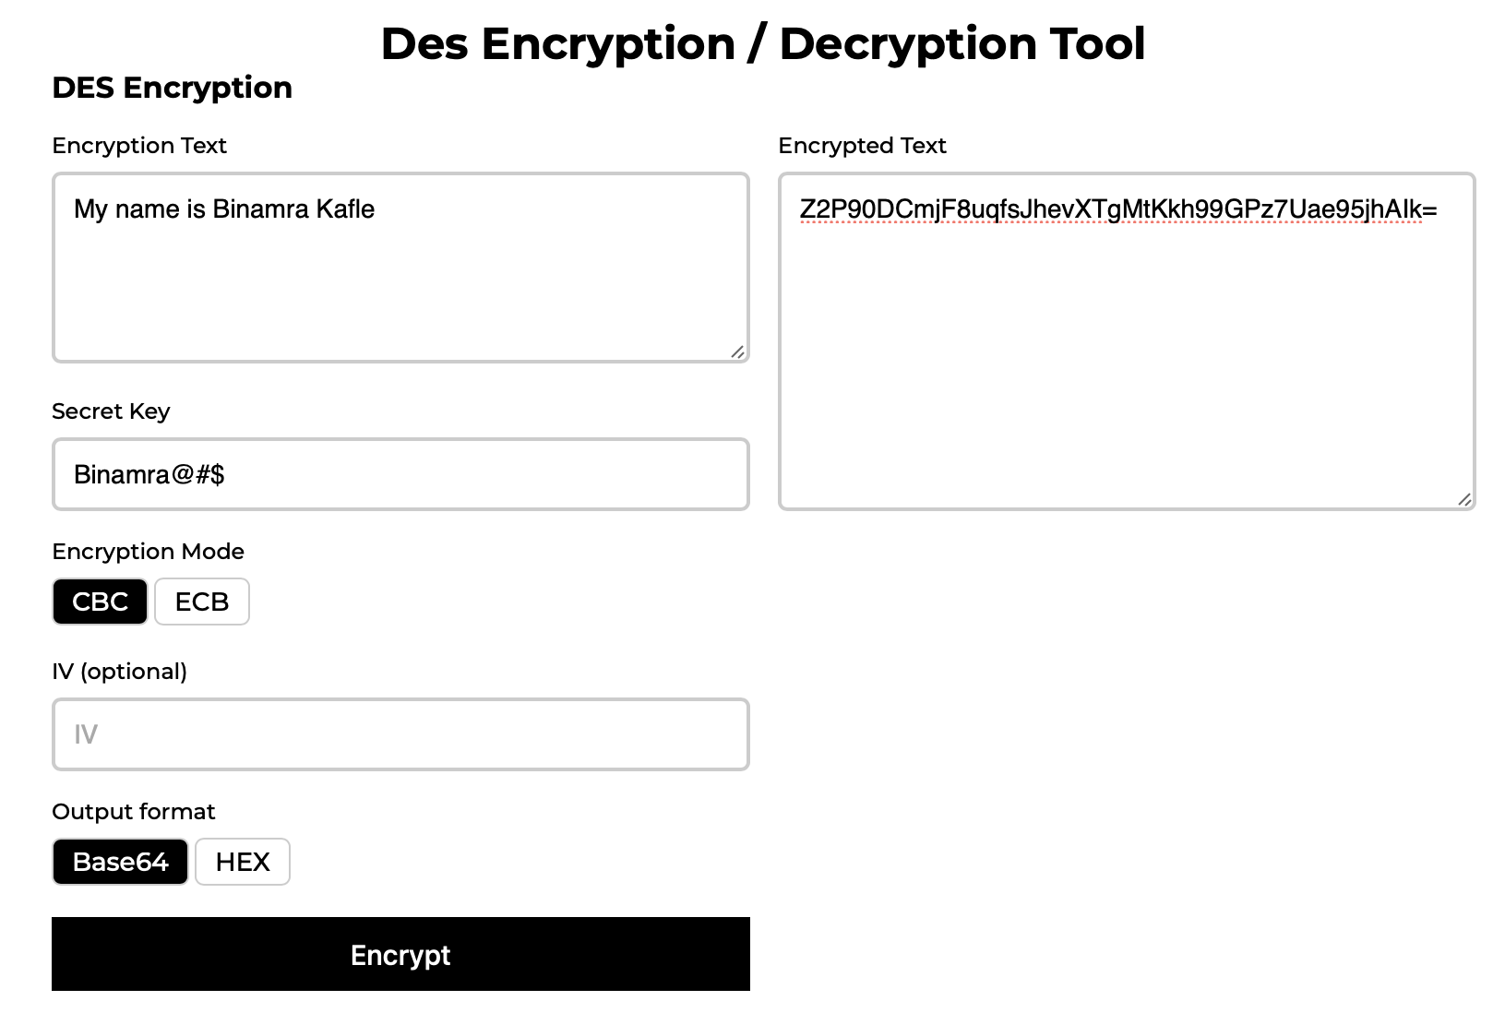

Decryption:

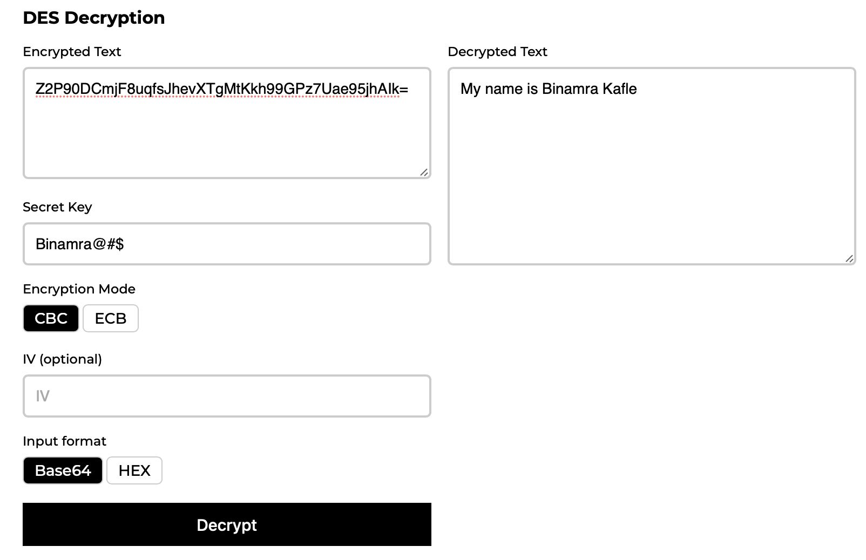

1. Test the AES algorithm for encryption and decryption by using online tool.

<https://anycript.com/crypto>

Encryption:

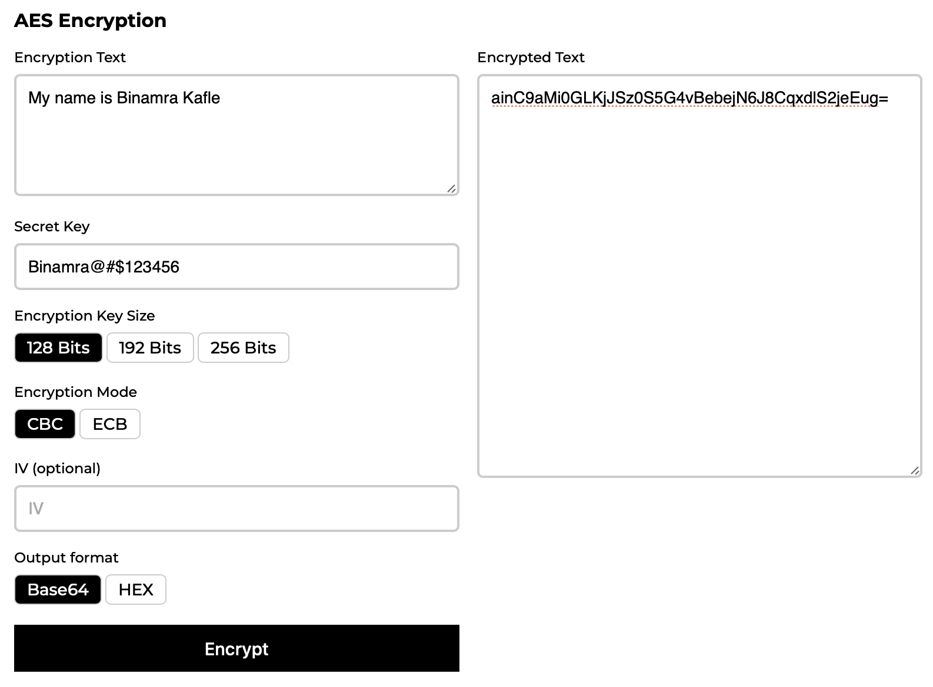

Decryption:

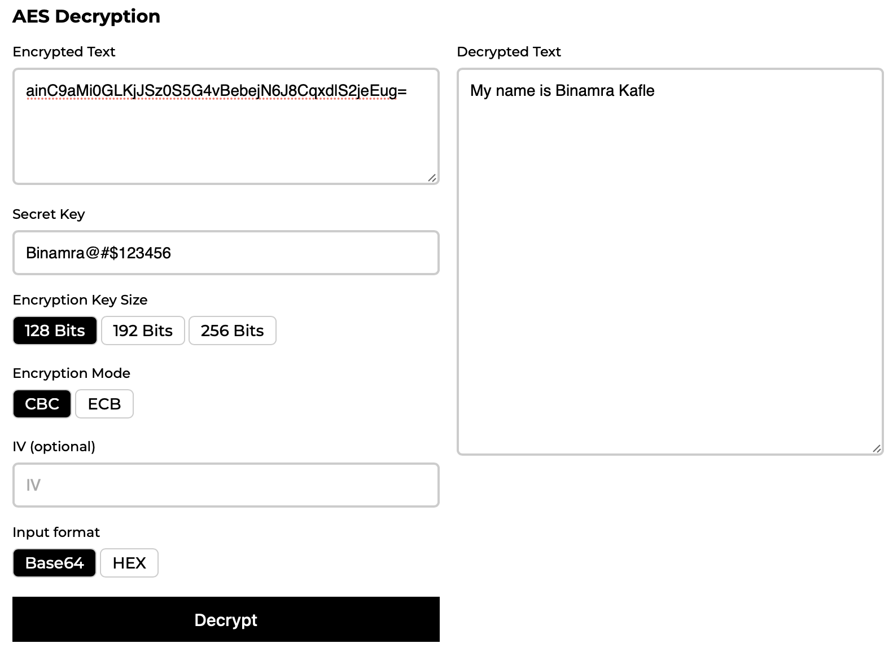

1. Test the SHA-256 by using some cryptographic tool to demonstrate.

<https://10015.io/tools/sha256-encrypt-decrypt>

Encryption:

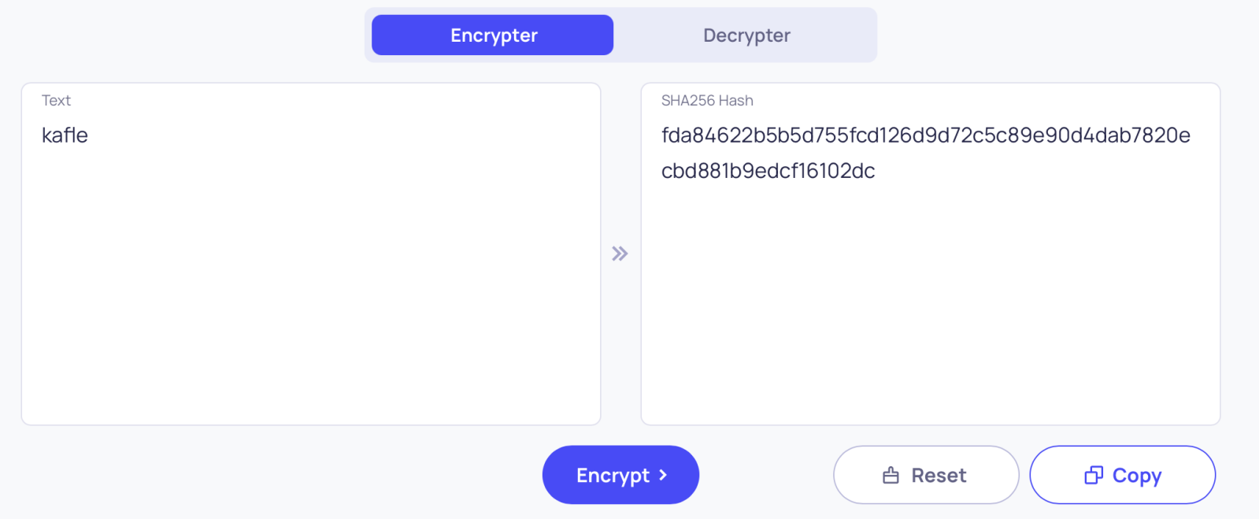

Decryption:

